Assignment 2 Report

COS80007 – Advanced Java

Abdul Moiz – 101727106

Alexander McWhae - 101801822

Mirza Akbar Beg - 101439582

Contents

Introduction 2

Lambdas and Streams in Validations 2

Lambdas in Event Handling 2

Database and Multi-threading 2

MVC 2

Pre-Integration 3

Improvements (Additional Features) 3

Screenshots 4

# Introduction

This software is a restaurant ordering and billing system and has been developed in Java. For implementing the Graphical User Interface, JavaFX has been used. This software enables the users in a restaurant to perform a list of activities such as placing an order, preparing it and billing the order at the end.

Two versions of this software have been implemented. The first version is the standalone prototype. The second one is based on the client-server communication and also involves database handling. In this version, three different instances of the application are run (customer, chef and biller) and these instances communicate with each other. This report contains an overview of the work done during the development of the software and also contains sequential screenshots of the application at the end.

# Lambdas and Streams in Validations

<Identify 4 places where these are used in the code>

# Lambdas in Event Handling

<Identify 4 places where these are used in the code>

# Collections/Generic Methods

<Identify 4 places where these are used in the code>

# Database and Multi-threading

# MVC

# Pre-Integration

<Put name of our pre integration folder here along with brief description>

# Improvements (Additional Features)

<2 improvements>

# Screenshots

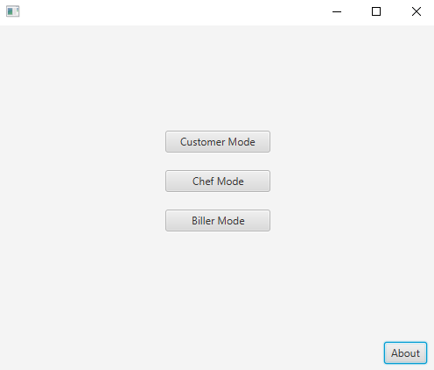

*Figure 1 –* Start-up Screen – Showing options for 3 different modes

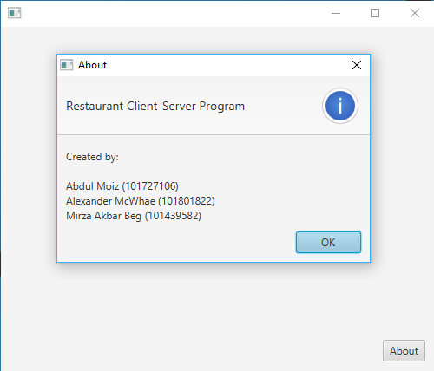

*Figure 2 –* About Dialog from Start-up Screen

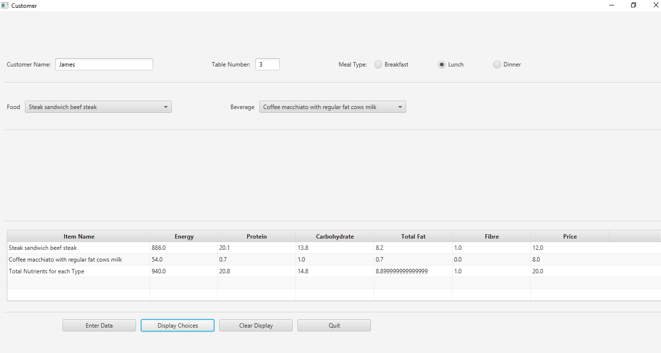

*Figure 3 – Customer Details and Order Selected – ‘Display Choices’ button displays the order in a table*

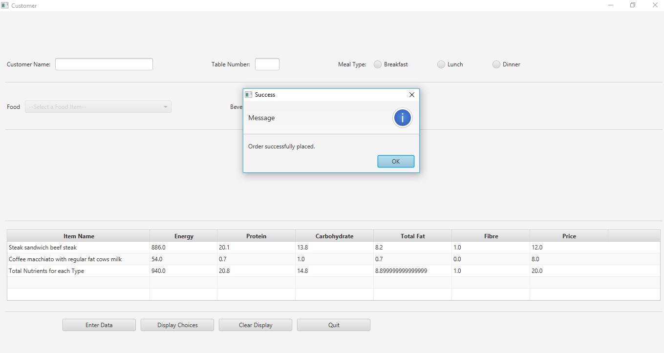

*Figure 4 – ‘Enter Data’ button places the order and shows confirmation dialog*

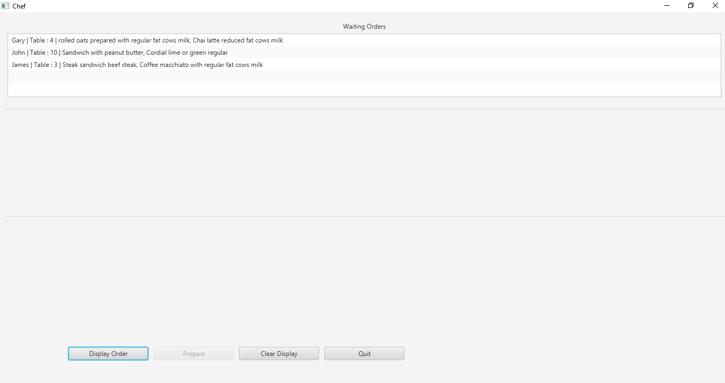

*Figure 5 –* The Chef application acts as the server and receives the order from Customer

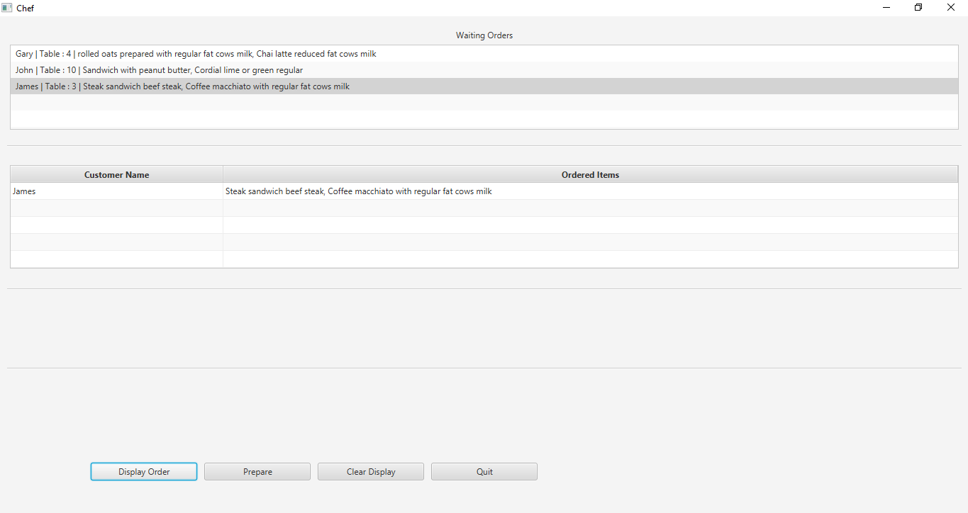

*Figure 6 – ‘Display Order’ button displays the selected order to the Chef*

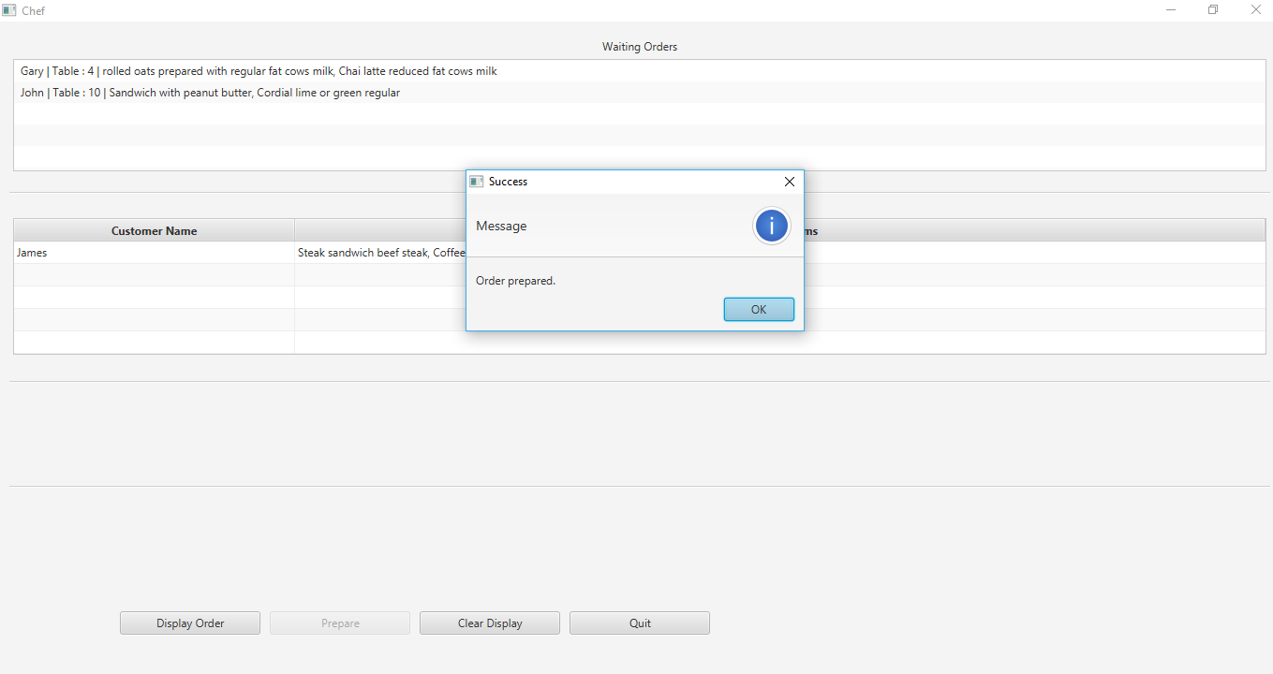

*Figure 7 – ‘Prepare’ button prepares the selected order and it is removed from the Waiting Orders List*

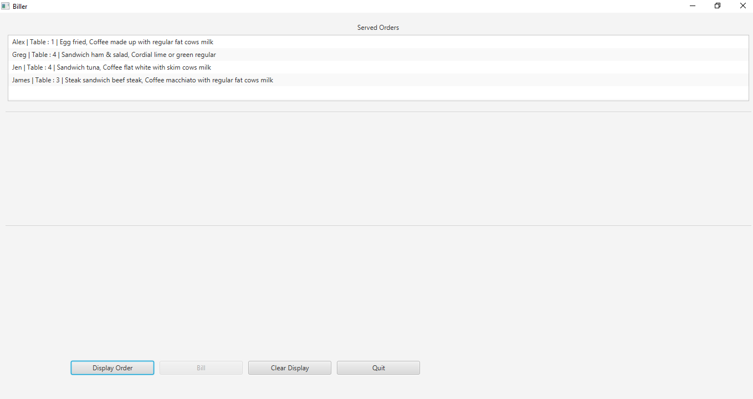

*Figure 8 – The Biller application receives the order from the Chef*

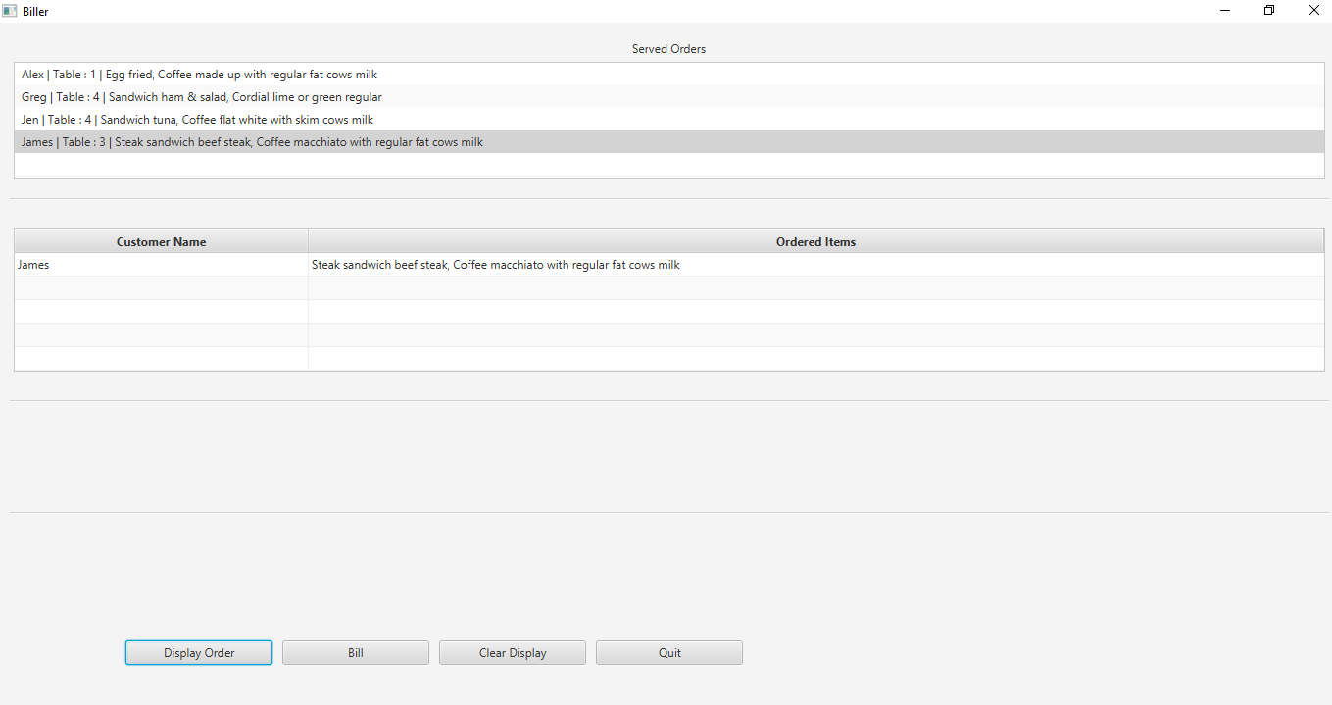

*Figure 9 – Clicking the ‘Display Order’ button displays the selected order for the Biller*

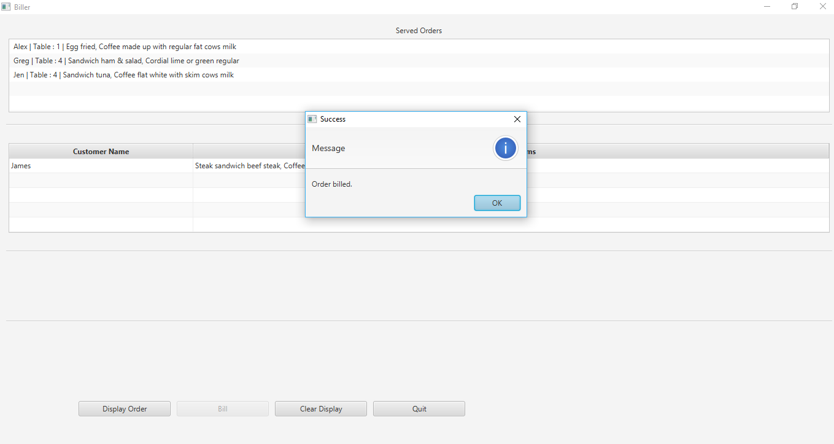

*Figure 10 – Clicking the ‘Bill’ button bills the order and displays confirmation message*